Bridgepoint Parts Catalog

Section XXIX: Nissan Engine Parts Page 1

PP42-902140

Air Filter – Nissan

Paper Filter Cartridge – Round

Prochem: 800A, Bear, Everest, Everest HP, Performer, Performer 405 & Power Vac II

PP42-902139

Oil Filter – Nissan

Prochem: 800A, Bear, Everest, Everest HP, Performer, Performer 405, Performer 805 & Power Vac II

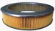
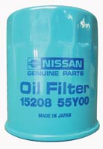

PP32-900029

Oil Pressure Switch
Prochem: Bear, Everest, Everest HP, Power Vac II, Performer & Performer 405

PNAFIL2222

Air Filter – Nissan

Paper Filter - Cylinder
Prochem: Performer 805
5-1/4” diameter x 11” long
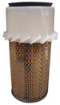
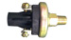

PP42-902137

Gasket – Valve Cover - Nissan
Prochem: 800A, Bear, Everest, Everest HP, Power Vac II, Performer & Performer 405

PP14-806507

Fuel Filter – Nissan Carburetor

Metal

Prochem: 800A, Bear &
older Performers
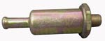

PP42-902143

Wire Set – Spark Plugs
Prochem: 800A, Bear, Everest, Everest HP, Power Vac II, Performer & Performer 405

PP42-902149

Solenoid – Fuel

Nissan Carburetor
Prochem: 800A, Bear, Everest, Everest HP, Power Vac II, Performer & Performer 405

PP42-902429

Wire Set – Spark Plugs

Prochem: Performer 805

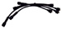

PP42-902198

Kit Carburetor Repair

Nissan
Prochem: 800A, Bear, Everest, Everest HP,
Power Vac II, Performer & Performer 405

PP42-902148

Spark Plug – Nissan
Prochem: 800A, Bear, Everest,
Everest HP, Power Vac II, Performer & Performer 405

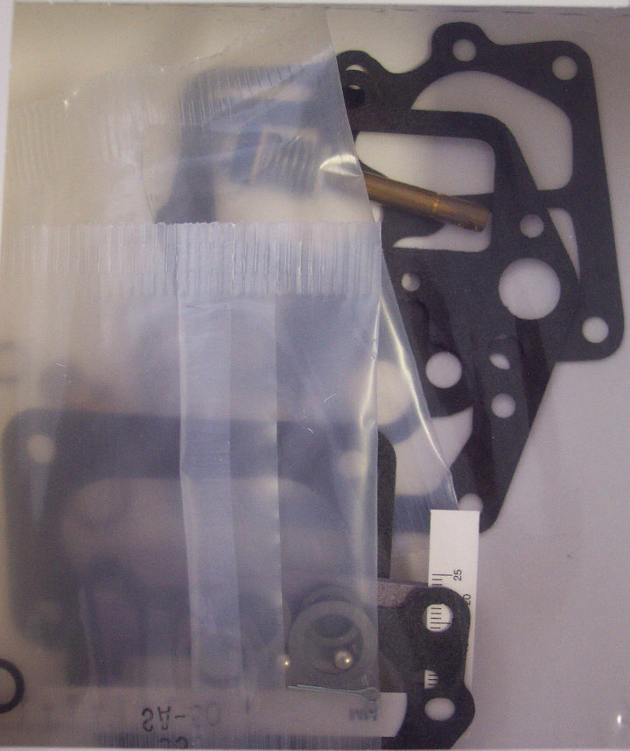
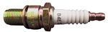

PP42-902208

Carburetor

Nissan 1992+

Prochem: Bear, Everest, Everest HP, Power Vac II, Performer & Performer 405

PP42-902428

Spark Plug – Nissan

Prochem: Performer 805

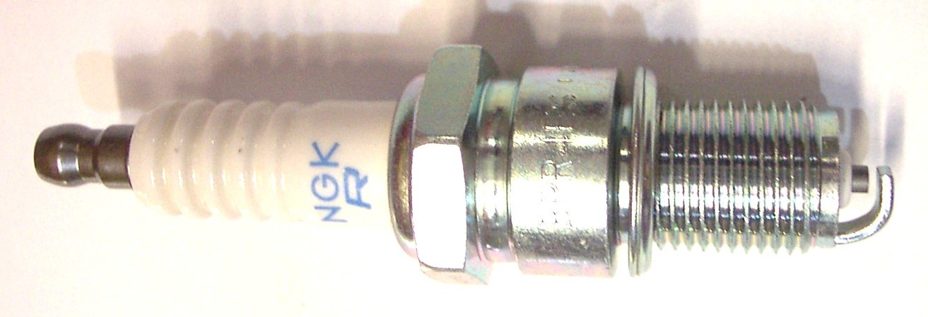

PP41-809085

Fuel Pump – Nissan

Mechanical – Old Style

(Prochem Part # 42-902184)
Prochem: 800A, Bear & older Performers

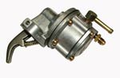

PP42-902189

Carburetor

Nissan Pre 1992

Prochem: 800A

PP42-902152

Gasket Fuel Pump – Nissan

Mechanical – Old Style

Prochem: 800A, Bear &
older Performers

PP42-902349

Water Pump – Nissan
Prochem: 800A, Bear, Everest, Everest HP, Power Vac II, Performer & Performer 405
(Gasket: PP42-902350)
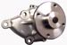

Bridgepoint Parts Catalog

Section XXIX: Nissan Engine Parts Page 2

PP42-902142

Distributor Cap – Nissan

Point Contact Ignition System

Prochem: 800A

PP42-902271

Distributor Cap – Nissan

Electronic Ignition System
Prochem: Bear, Everest, Everest HP, Power Vac II, Performer & Performer 405

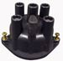

PP42-902151

Rotor – Nissan Distributor

Point Contact Ignition System

Prochem: 800A

PP42-902272

Rotor – Nissan Distributor

Electronic Ignition System
Prochem: Bear, Everest, Everest HP, Power Vac II, Performer & Performer 405

PP42-902165

Points – Nissan Distributor

Point Contact Ignition System

Prochem: 800A

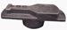
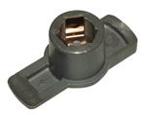

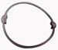

PP42-902153

Seal – Nissan Distributor Cap Electronic Ignition System
Prochem: Bear, Everest, Everest HP, Power Vac II, Performer & Performer 405

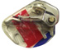

PP42-902166

Condenser – Nissan Distributor

Point Contact Ignition System
Prochem: 800A

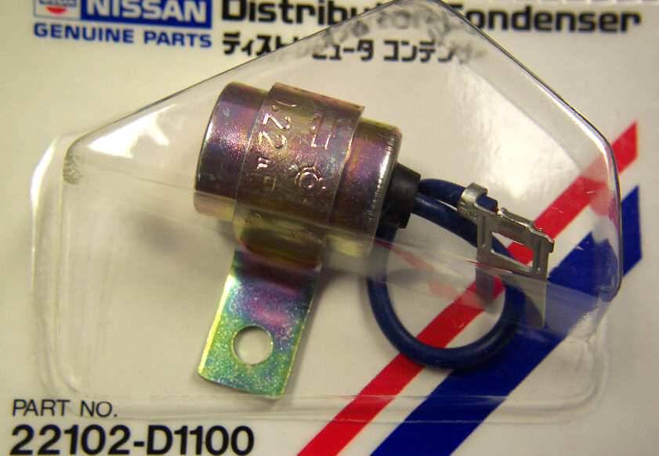

PP42-902352

lgnition Module – Nissan Electronic Ignition System
Prochem: Bear, Everest,
Everest HP, Power Vac II, Performer & Performer 405

PP35-900052

Thermostat – 195 Deg

Nissan Engine
Prochem: 800A, Bear, Everest, Everest HP, Power Vac II, Performer & Performer 405

PP42-902144

Coil – Nissan Ignition
Prochem: 800A, Bear, Everest, Everest HP, Power Vac II, Performer & Performer 405

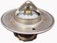
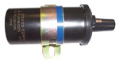

PP42-902146

Starter – Nissan Engine
Prochem: 800A, Bear, Everest, Everest HP, Power Vac II, Performer & Performer 405

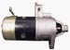
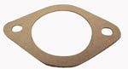

PP43-807067

Gasket - Thermostat

Nissan Engine
Prochem: 800A, Bear, Everest, Everest HP, Power Vac II, Performer & Performer 405

PP42-902147

Solenoid Starter – Nissan
Prochem: 800A, Bear, Everest, Everest HP, Power Vac II, Performer & Performer 405

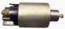

PP42-902199

Governor – Nissan Engine
Prochem: 800A, Bear, Everest, Everest HP, Power Vac II, Performer & Performer 405
Throttle Rod – PP42-902200

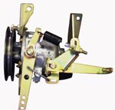

PNA44-4518

Starter – Nissan Engine

Reconditioned
Replacement for PP42-902146 &
PP42-902147

PP42-902188

Alternator – Nissan Engine
Prochem: 800A, Bear, Everest, Everest HP, Power Vac II, Performer & Performer 405

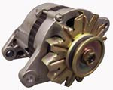

PP42-902138

PCV Valve – Nissan
Prochem: 800A, Bear, Everest,
Everest HP, Power Vac II, Performer & Performer 405

